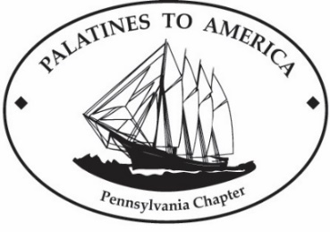
Palatines to America
2026 National Conference

Our German Ancestors: Building America
DEADLINE FOR PROPOSALS: October 15, 2025

Presented by Palatines to America German Genealogy Society (PalAm)
Hosted by the Pennsylvania Chapter of PalAm
In-person conference in Lancaster, Pennsylvania

The Pennsylvania Chapter of Palatines to America welcomes proposals for the 2026 National PalAm Conference. The theme is Our German Ancestors: Building America. The conference will be June 18–20, 2026 at the DoubleTree Resort by Hilton in Lancaster, PA, with presentations on Friday, 6/19 and Saturday, 6/20.

We are seeking presentations from dynamic speakers on the following topics as they relate to the theme, and to Germans, Pennsylvania Germans, or local genealogy and history:
- Religious Movements and Migration
- Military and Civic Service
- Economic Contributions (land, trades, occupations, businesses, etc.)
- Immigration and Naturalization
- Migration Patterns
- Cultural Contributions (language, food, traditions, etc.)
- Research Resources

Other topics will be considered if the presentation relates to the conference theme. We will have a limited number of presentation slots at the conference. Proposals not selected for the conference will be considered for our ongoing Third Tuesday Zoom sessions.

Presentations should be 50 minutes followed by 10 minutes for questions. Details about proposals and the submission form are linked from 2026 PalAm National Conference.

Please submit questions to programming@pennpalam.org.

Palatines to America is a German genealogical society with over 700 members who belong to Chapters in six different states. We are passionate about researching the life and times of our German-speaking ancestors. PalAm is incorporated as a non-profit organization and is an approved charitable organization under Section 501(c)(3) of the Internal Revenue Service Code.

